**BANK APPLICATION**

**The Bank Application has three users:**

1. Admin.
2. Manager.
3. Clerk.

**Users and their roles:**

1. **Admin:** Among all the users, Admin can perform all actions on an account. The actions include creating new account, create new user for the application, suspend an account and delete an account.
2. **Manager:** Manager is also a user who has limited actions. The actions include update account, Transfer fund that required approval.
3. **Clerk:** Clerk is the low tier user who can only perform action fund transfer and get transaction history.

**Actions Performed:**

1. **Login**: This is used to login for particular person. If login fails he/she will be redirected to home page.

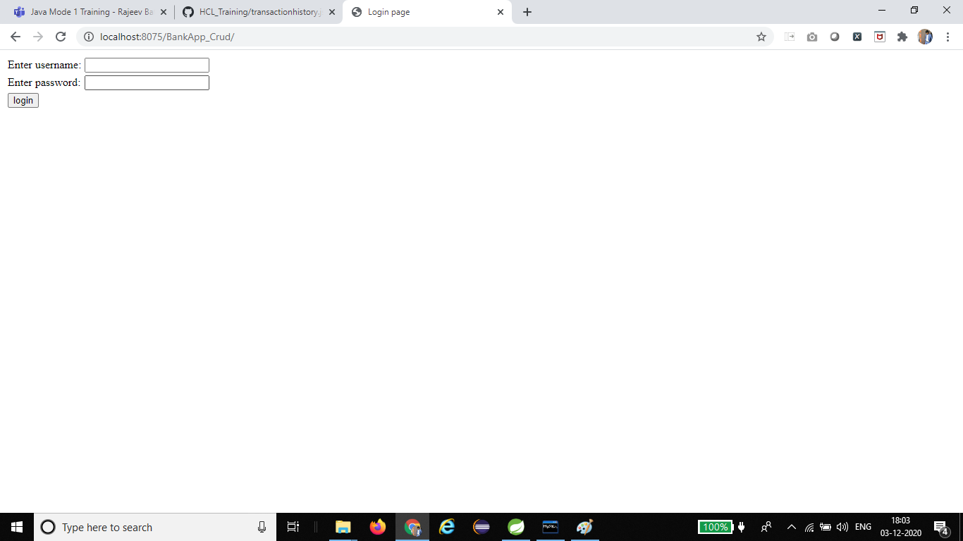

This is the first step. Here the users like Admin, Manager and Clerk can login in to this Bank Application if the user has Account or else user has to create a new account.



* Admin Login: Admin can login if he/she has account in Bank Application.

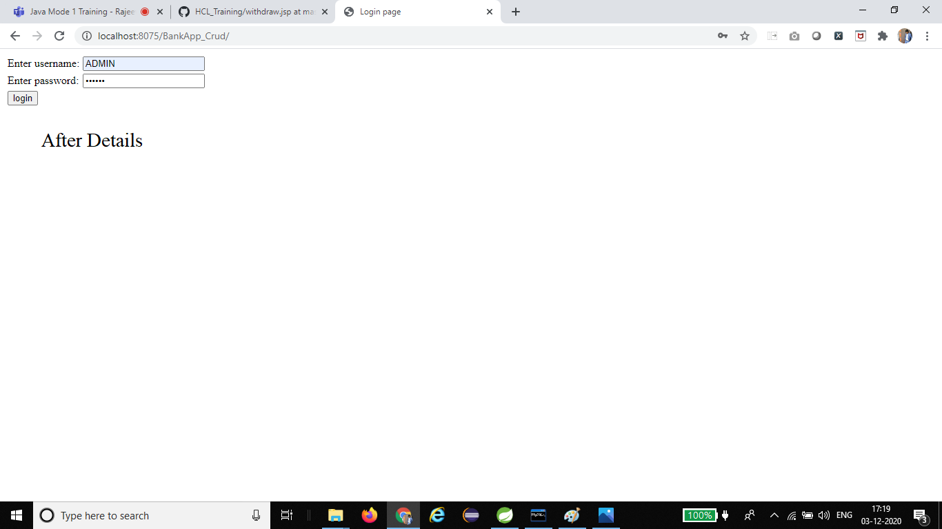

Admin can do operations like Show all accounts, Show all users, Create new account, New add user, Transfer Money, Withdraw Money and Deposit Money.

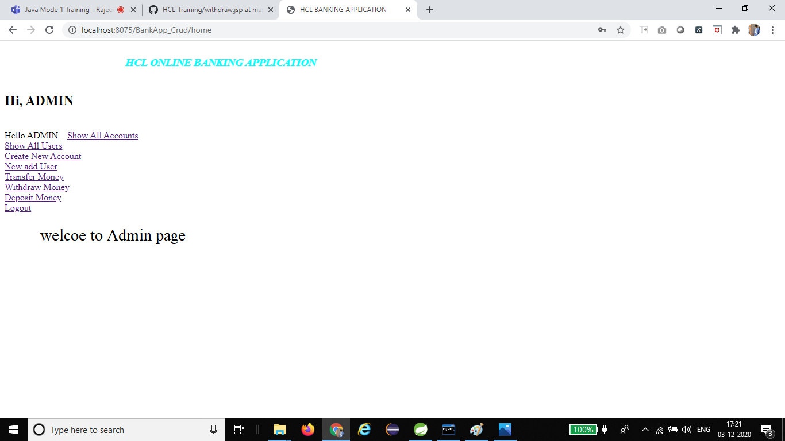

* Manager Login: Manager can login if he/she has account in Bank Application.

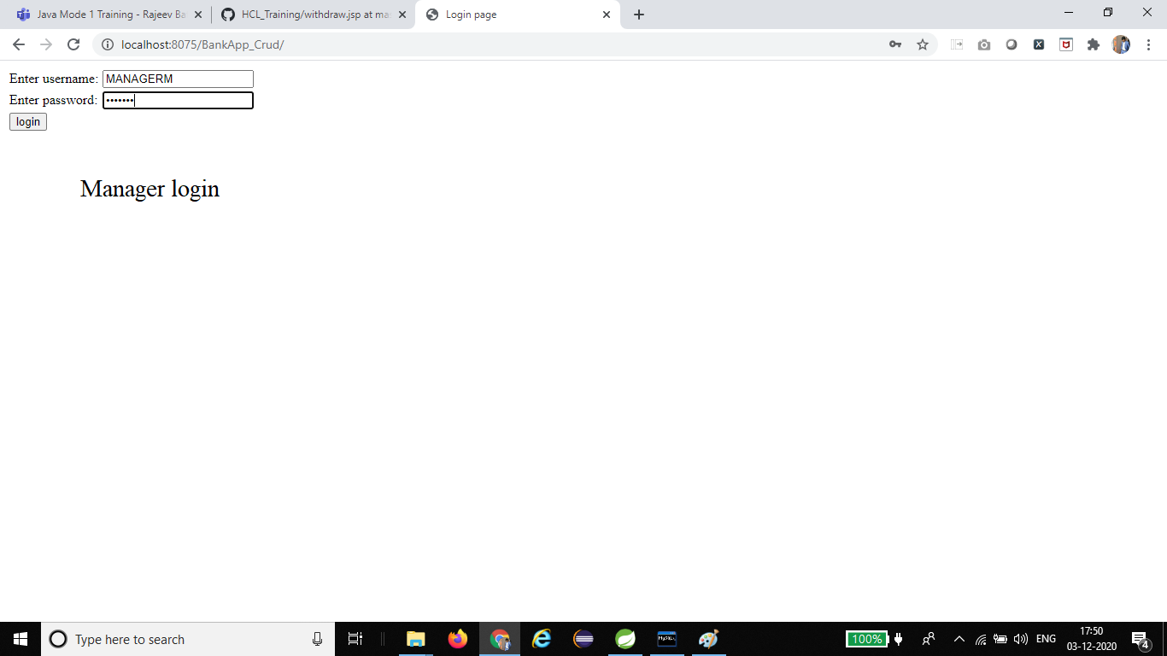

Manager can do operations like Show all accounts, Show all users, Transfer Money, Withdraw Money, Deposit Money.

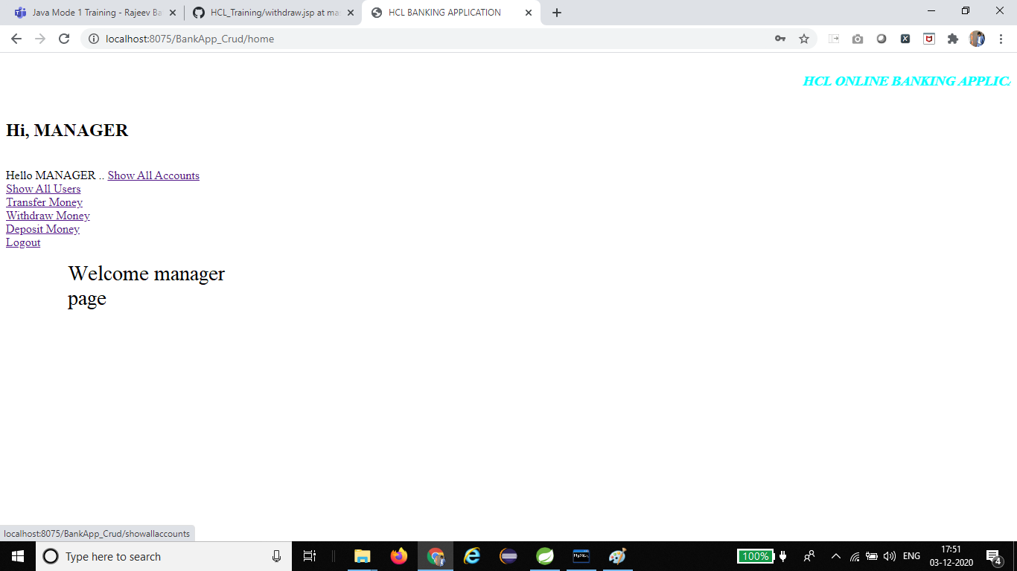

* Clerk Login: Clerk can login if he/she has account in Bank Application.

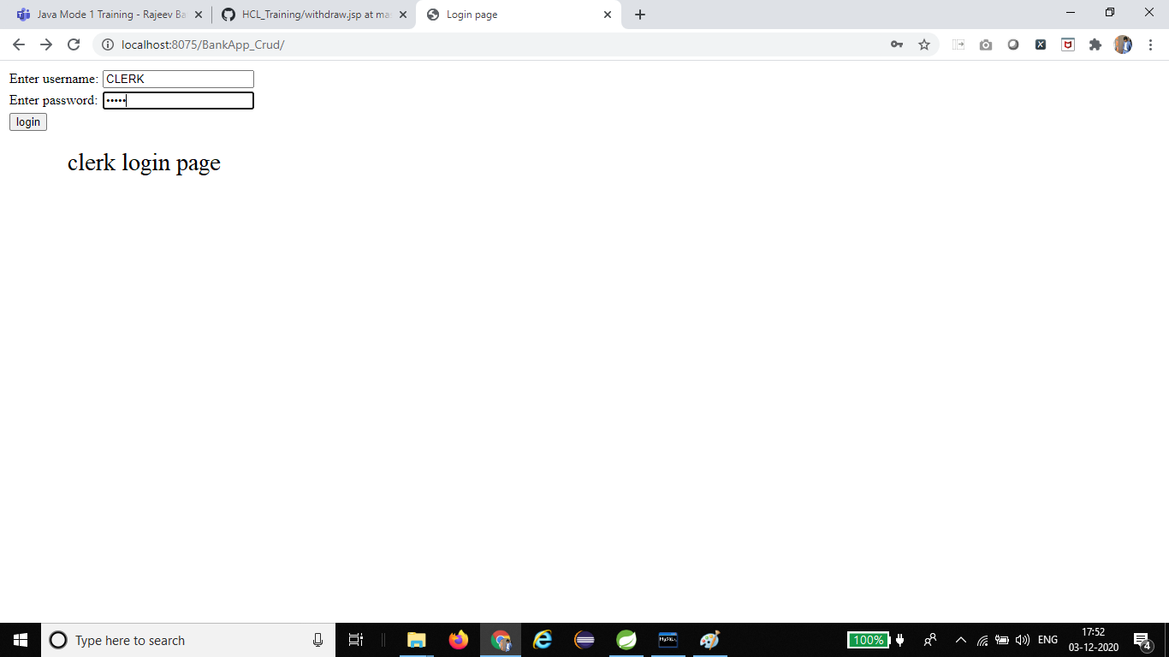

Clerk can do some operations like Show all accounts, Transfer Money, Withdraw Money, Deposit Money.

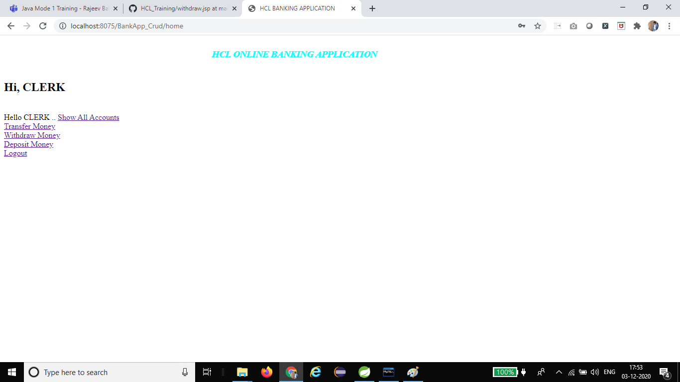

1. **AddUser**: This action allows us to add user. The inputs are username, password, user type, address, phone number, email, aadhar card and pan card.

Here we can add a new user for Admin, Manager and Clerk.

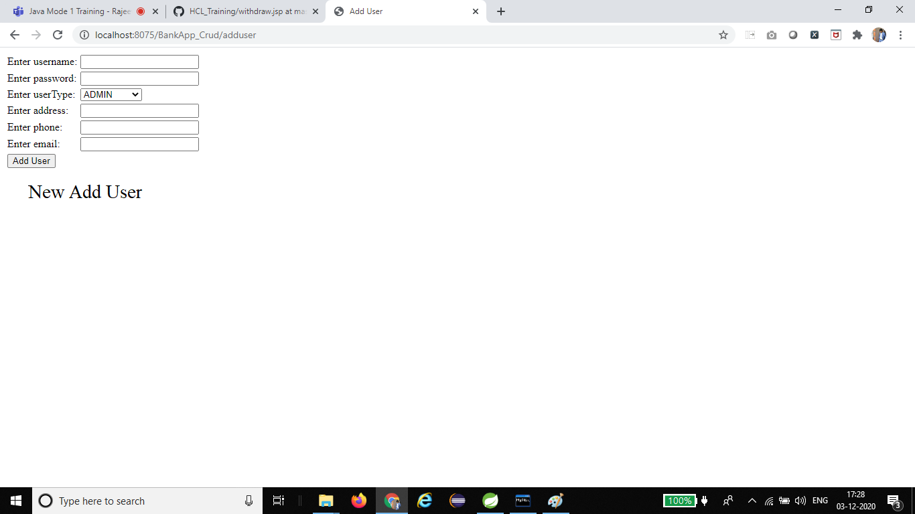

1. **Deposit:** This action allows us to deposit money in user account. It takes parameters like account number and amount to be deposited.

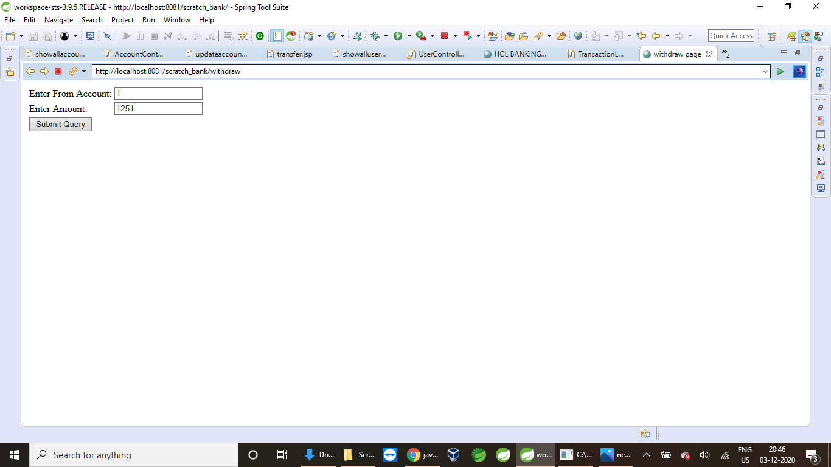

Once the money is successfully deposited

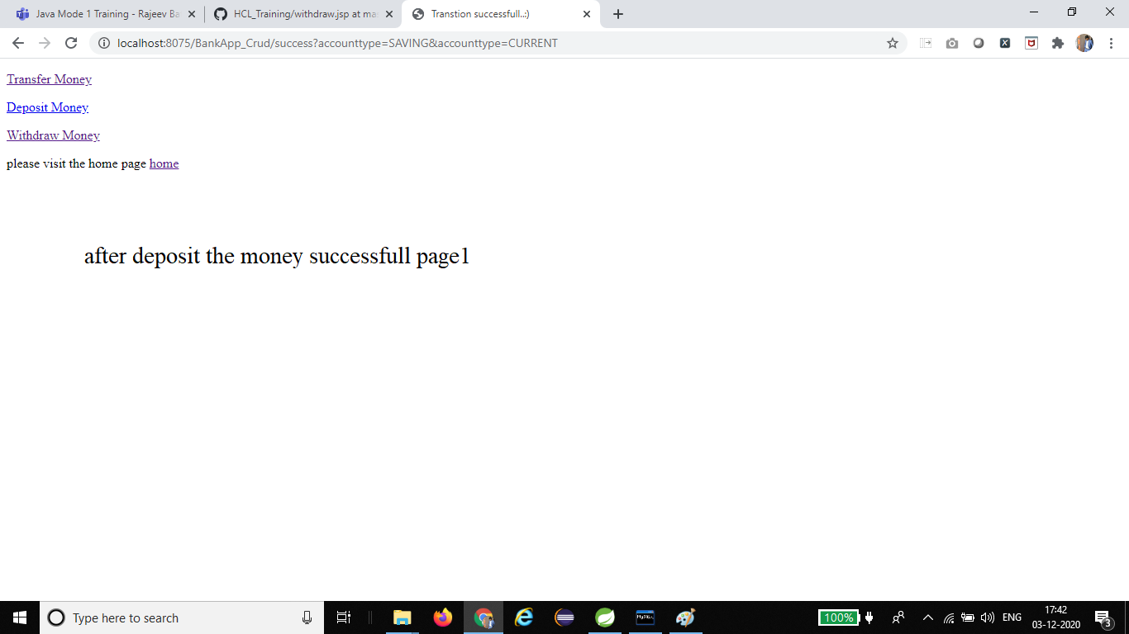

1. **Withdraw:** This action allows the user to withdraw money from his account. It takes two parameters like account number and amount to withdraw.

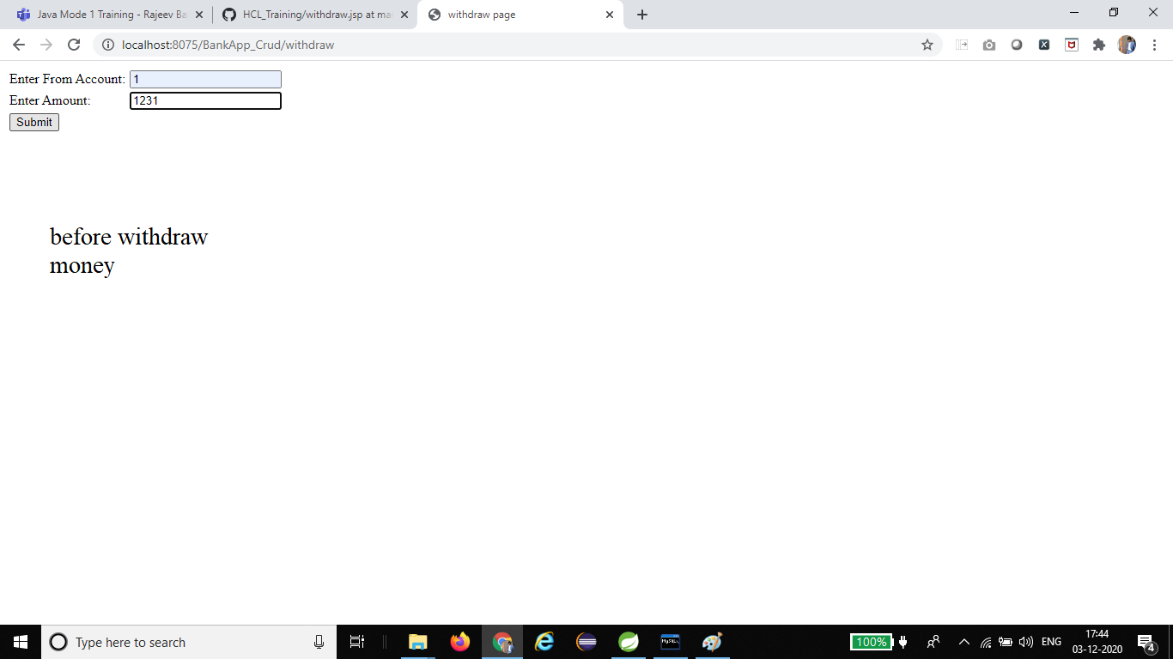

Once the money is Successfully Withdrawn

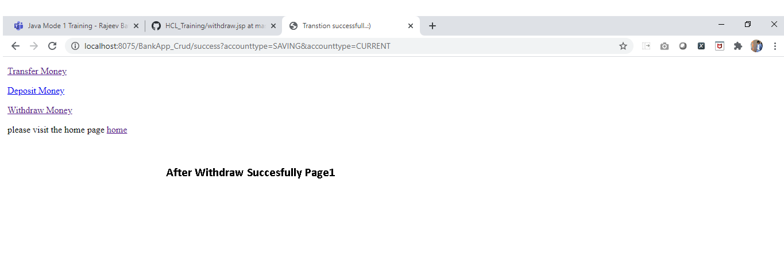

1. **Fund Transfer:** This action allows an user to transfer fund from one account to another. It takes 3 parameters from account number, to account number and amount to transfer.

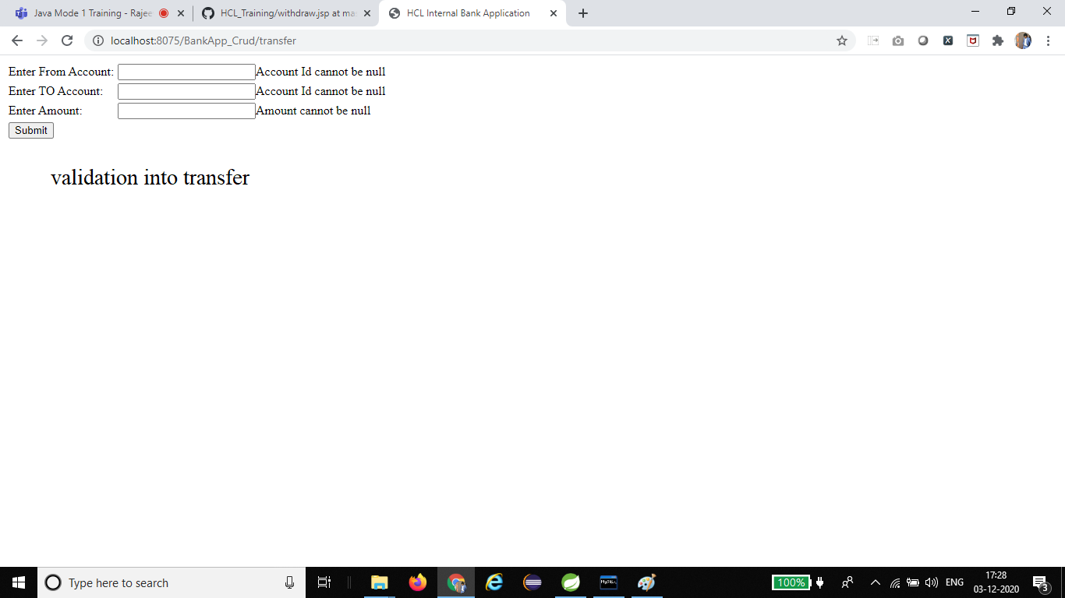

1. **AddAccount:** It is similar to add user but it takes an extra input called user type which indicates whether the user is an admin, manager or clerk.

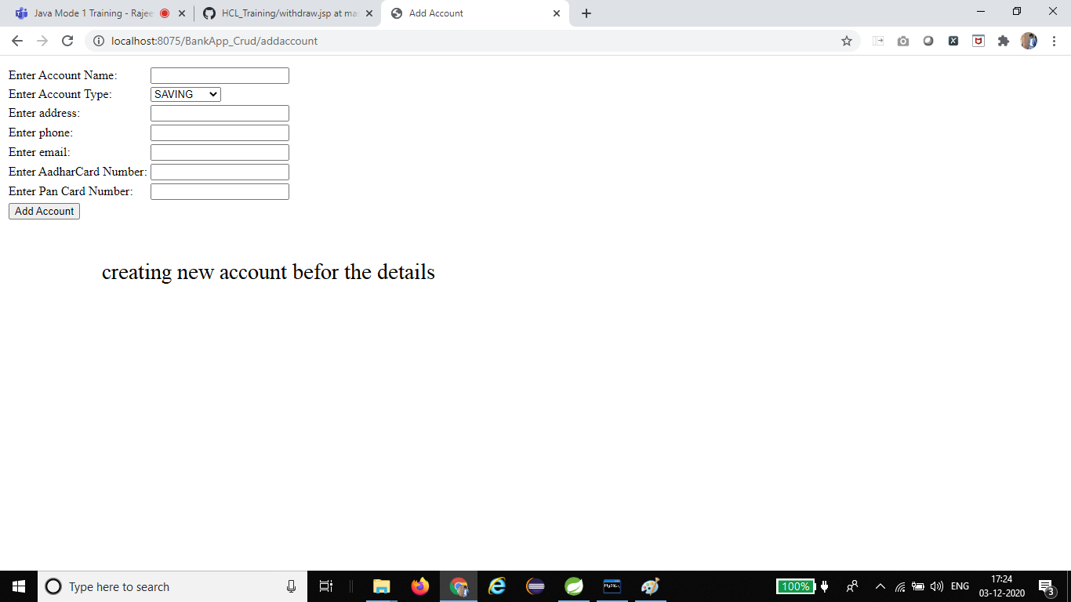

1. **ShowAllAccounts:** Show all accounts is used to display all the accounts in the accounts table.

Here we can see all the account details of users.

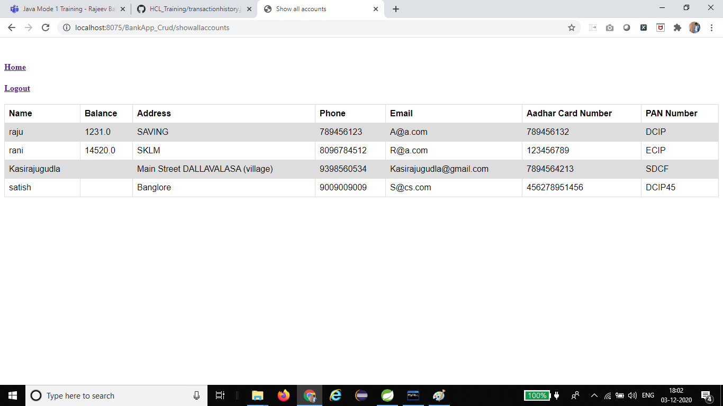

1. **ShowAllUsers:** Show all users is used to display all the users in the users table which include admin, manager or clerk.

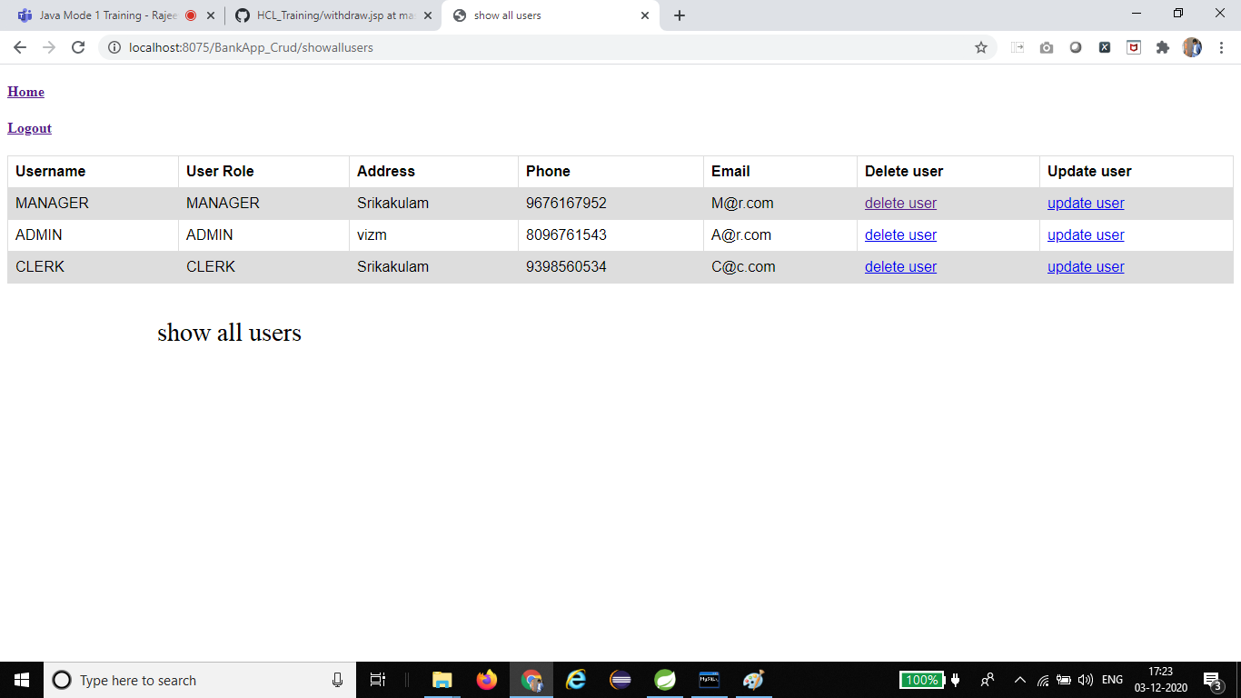

1. **UpdateAccount/UpdateUser:** Used to update details for an user or an account.

**Validations:**

**Account number:** Account number is validated by checking whether it is already existing in database or not.

**Withdraw:** The amount for withdraw will also be validated since it should always be less than the current balance.

**Fund Transfer:** Fund transfer also requires validation for both account numbers and money to be transferred.

* Validations also include not null(which indicates that the details should be filled), should enter number(should enter number only), should enter string(should enter string only) etc.

**Updating User/Account:**

While updating user/account only specific data can be updated. The data are Address, Phone and Email.

* Aadhar card and Pan card cannot be updated for an user/account.
* The type of user can also be changed by the admin.